**PRACTICAL: 8**

**AIM:**

Verify data integrity using the following tools: HashCalc, and MD5 Calculator.

**THEORY:**

**Hashing:** It is the process of utilising an algorithm, such as Secure Hash Algorithm version 1 (SHA1) and Message Digest version 5, to hash the data included in a document (MD5). This generates a hash value, commonly referred to as a message digest, from the contents contained in the file.

A hash value can be used to check the integrity of data. The hash value is often safeguarded in some fashion and data is typically hashed at a specific time. The data can be hashed once again and compared to the protected value afterwards. The data has not been changed if the hash values match. The data has been corrupted if the values do not match. The protected hash must be encrypted or kept secret from all untrusted parties in order for this system to function.

**Verifying Integrity:** During forensic analysis, the scientist takes a copy of the data prior to investigation. To ensure that he/she has not tampered with it during investigation, he/she will hash the data before starting and then compare the hash to the data when he/she has finished. If the hash matches, then we know that the integrity of the data is intact.

**HashCalc**: A fast and easy-to-use calculator that allows to compute message digests, checksums and HMACs for files, as well as for text and hex strings. It offers a choice of 13 of the most popular hash and checksum algorithms for calculations.

**MD5 Calculator**: MD5 Calculator is a free, simple and easy-to-use MD5 hash value calculation tool, it can quickly calculate, export, import, copy and check MD5 checksum.

**OUTPUT:**

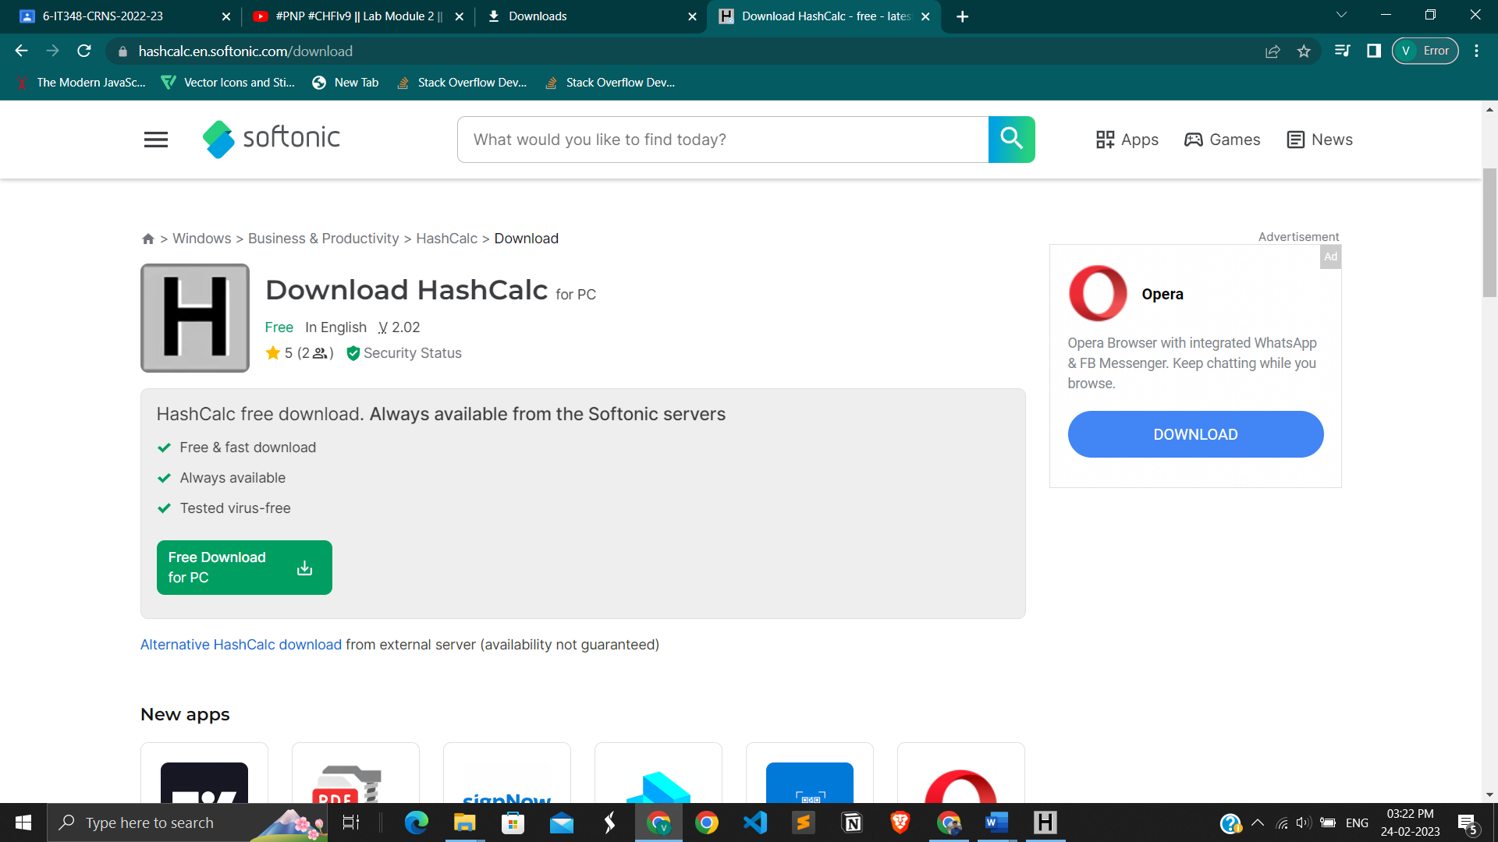

Download an HashCalc from website

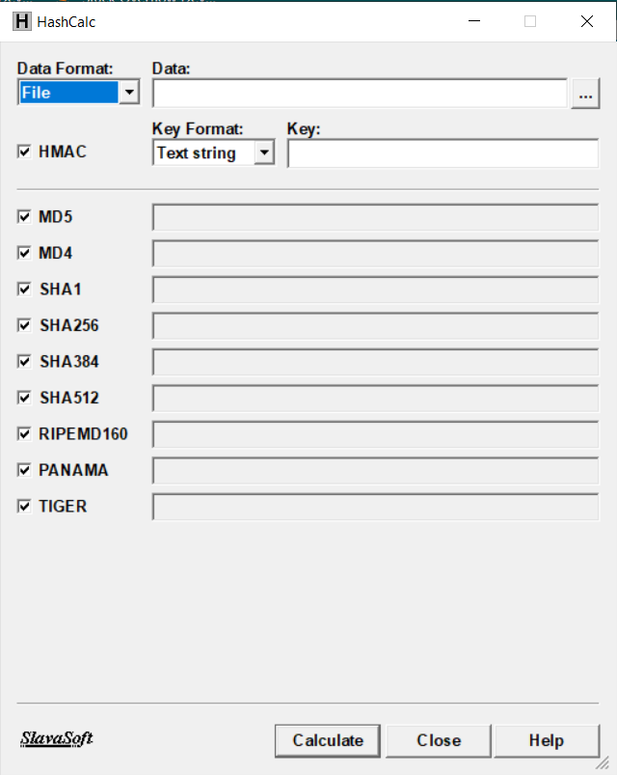

Interface of HashCalc

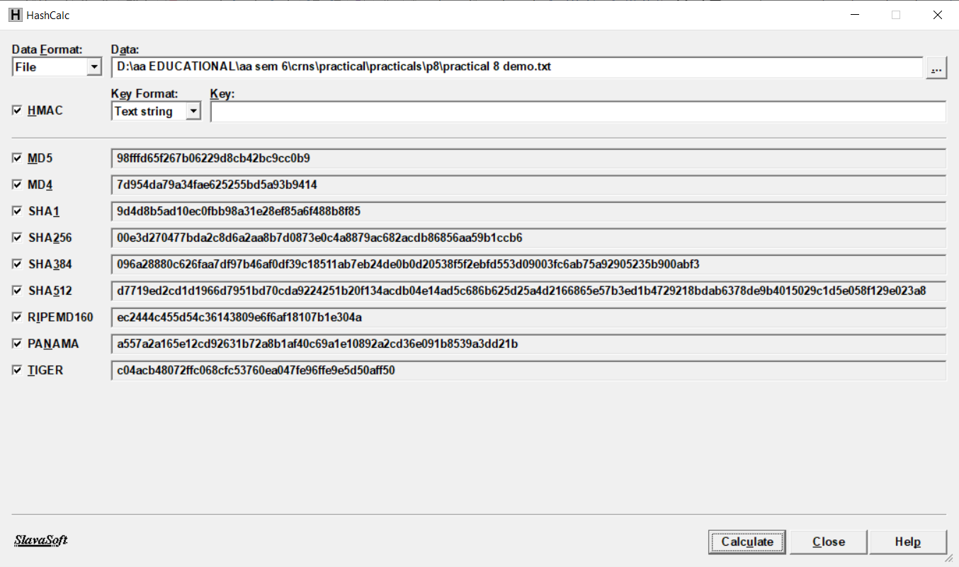

Created a file called demo.txt and push into HashCalc and calculate the hash values

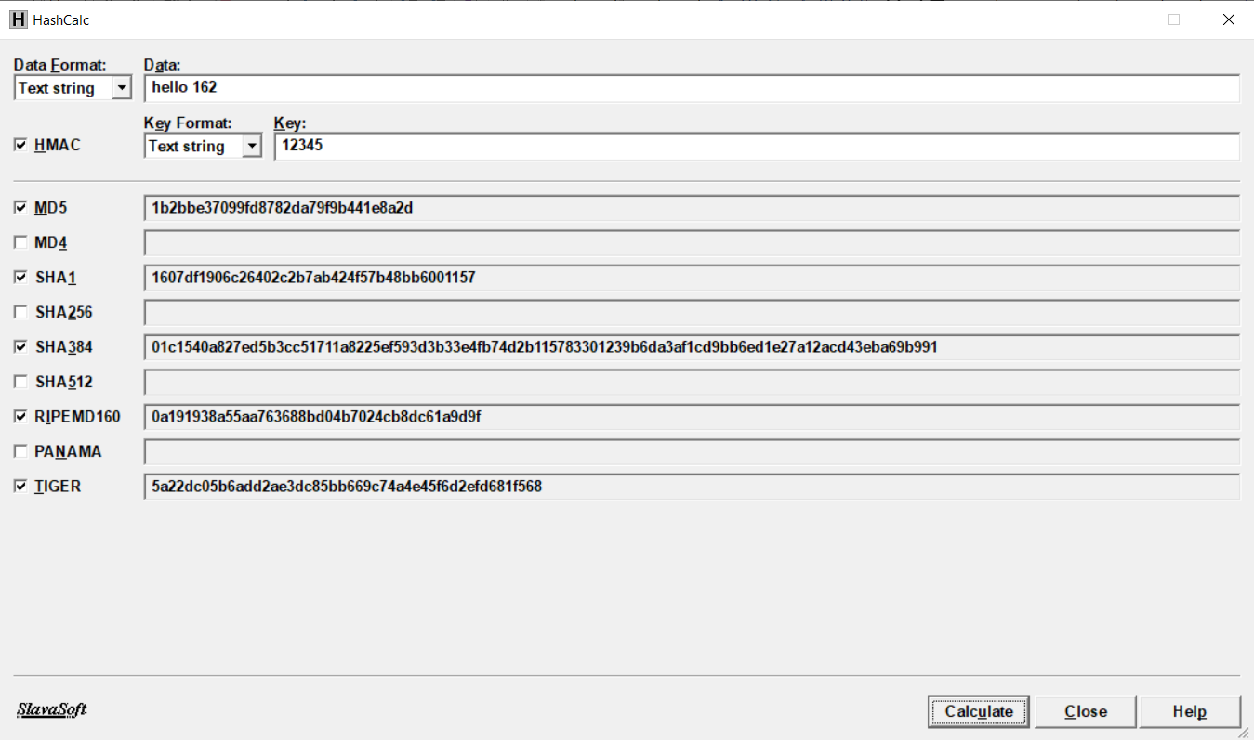

Written an data and a key to generate a hash values

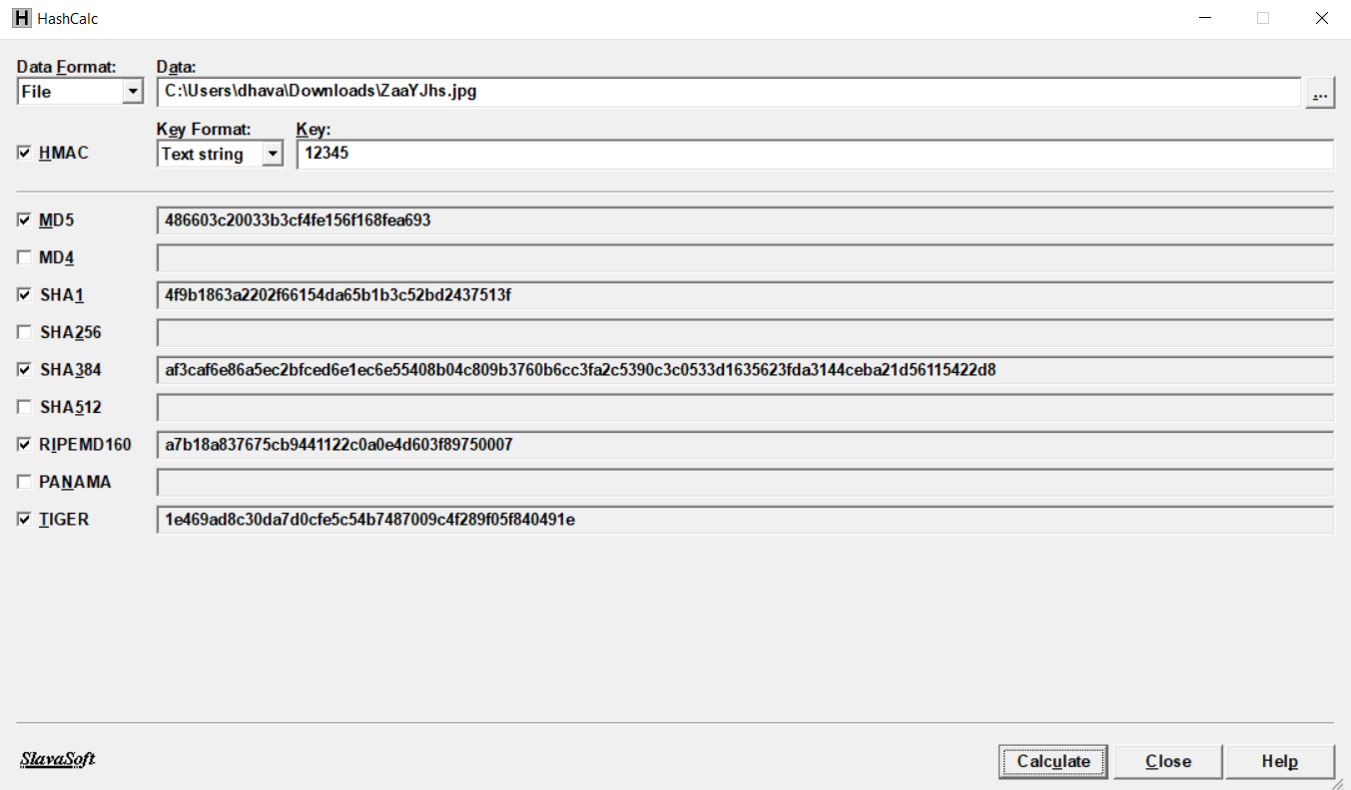

Generated a hash value of .jpg file

**MD5 calculator:**

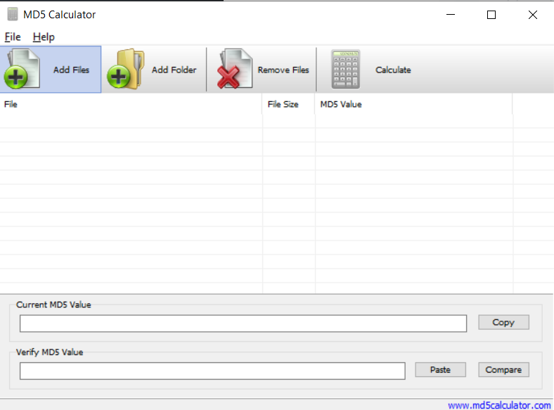

Interface of MD5

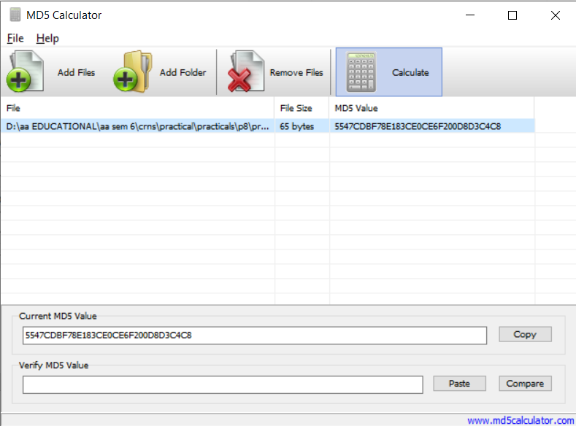

Added a .txt file and generate a hash value

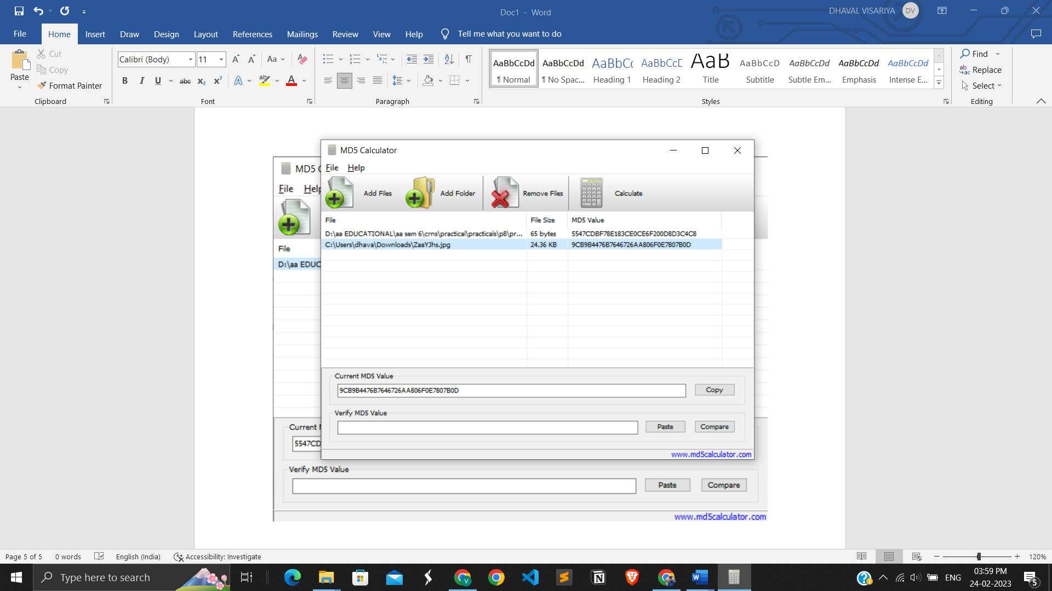



Added an .jpg file and generate an hash value.

**LATEST APPLICATIONS:** Hashing is a function used to map data to a fixed-length value. Businesses use hashing in authentication systems and to validate different types of data, such as files and documents. Understanding what hashing is and how it's used is important because it can help to prevent data breaches and protect stored information. In this article, we explain what hashing is, why it's important, when it's used and how it works, along with a real-world example.

Hashing is important because it offers a method for retrieving data that's secure and efficient. It's also quicker than most traditional sorting algorithms, which makes it more efficient for retrieving data.

**LEARNING OUTCOME:** By creating a hash code or comparing two different files or images, I may learn how to recognise and tell them as they are same or different**.**

**REFERENCES:**

1. HashCalc: [www.md5calculator.com](http://www.md5calculator.com)
2. MD5 calculator: <https://hashcalc.en.softonic.com>